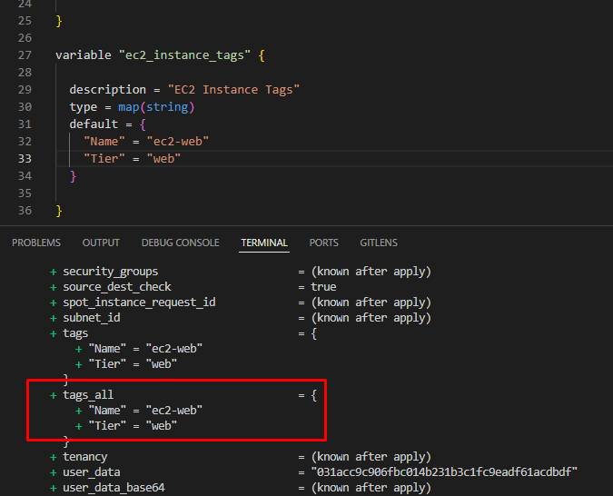

**Step-08-02: Implement Vairable Type as Map**

- **\*\*map (or object):\*\*** a group of values identified by named labels, like {name = "Mabel", age = 52}.

- Implement Map function for variable `ec2_instance_tags`

```t

# Implement Map Function for tags

variable "ec2_instance_tags" {

  description = "EC2 Instance Tags"

  type = map(string)

  default = {

    "Name" = "ec2-web"

    "Tier" = "Web"

  }

# Reference Values from Map in ec2-instance.tf

tags = var.ec2_instance_tags

# Implement Map Function for Instance Type

# Important Note: comment "ec2_instance_type" variable with list function

variable "ec2_instance_type_map" {

  description = "EC2 Instance Type using maps"

  type = map(string)

  default = {

    "small-apps" = "t3.micro"

    "medium-apps" = "t3.medium"

    "big-apps" = "t3.large"

  }

# Reference Instance Type from Maps Variables

instance_type = var.ec2_instance_type_map["small-apps"]

instance_type = var.ec2_instance_type_map["medium-apps"]

instance_type = var.ec2_instance_type_map["big-apps"]

